Chapter 16 Summary Notes
Main Concepts | Explanations
Acids and Bases Definitions  - Arrhenius definition  - Acids: produce protons; increase [H⁺]  - Bases: produce hydroxides; inc. [OH⁻]  - Brønsted-Lowry definition  - Acids: H⁺ donor  - Bases: H⁺ acceptor  - Lewis definition  - Acids: electron pair acceptor  - Bases: electron pair donor  pH Scale  - pH = -log[H⁺] = -log[H₃O⁺] or [H⁺]= 10^{-pH}  - pOH = -log [OH⁻] or [OH⁻] = 10^{-pOH}  - pH + pOH = 14.00  - 7 is neutral, <7 is acidic, >7 is basic  Key Terms  - Amphoteric: capable of acting as either an acid or base. Common amphoteric substances are H₂O, transition metal cations (Al³⁺, Fe³⁺ etc.), transition metal hydroxides Fe(OH)_{3,} Cu(OH)₂ etc. and conjugate bases of polyprotic acids such as HSO₃⁻ etc.  - Polyprotic acids have at least one H⁺  - Hydrolysis: acid/base reaction of ion with water to produce H⁺ or OH⁻  - Anion (A⁻) = a conjugate base  A⁻ (aq) + H₂O (l) ↔ HA (aq) + OH⁻ (aq)  - Cation (B⁺) = a conjugate acid  B⁺ (aq) + H₂O (l) ↔ BOH (aq) + H⁺ (aq)  Acid-Base Behavior  - Strong acids and bases fully ionize in water (equilibrium is shifted “entirely” toward ions).  - Stronger acids, HA, have:  - H with a higher d⁺  - Weaker H-A bonds (smaller bond energies)  - More stable conjugate bases A⁻  - Stronger oxyacids, H_{x}O_{z}-Y, have:  - Central nonmetal “Y” with higher electronegativity  - More O atoms | 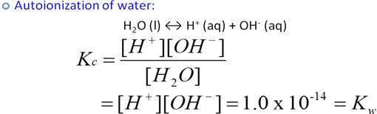  pH + pOH = 14.00  Zinc Oxide acting amphoteric:  In acid: ZnO + 2H⁺ → Zn²⁺ + H₂O  In base: ZnO + H₂O + 2OH⁻ → [Zn(OH)₄]²⁻  $K_{b}×K_{a}=K_{w}=1\text{.}0×{\text{10}}^{−\text{14}}$${\text{pK}}_{b}+{\text{pK}}_{a}={\text{pK}}_{w}=\text{14}\text{.}\text{00}$$K_{a}=\frac{[H^{+}][A^{−}]}{[\text{HA}]_{\text{eq}}}$Weak Acid Ionization  HA (aq) ↔ A⁻ (aq) + H⁺ (aq)  Use ICE chart to calculate pH of a weak acid or base.  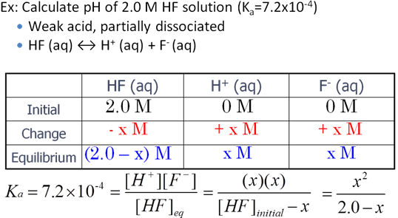  $K_{b}=\frac{[{\text{BH}}^{+}][{\text{OH}}^{−}]}{[B]_{\text{eq}}}$Weak Base Ionization  B (aq) + H₂O (l) ↔ BH⁺ (aq) + OH⁻ (aq)  $\text{\% Ionization}=\frac{[H^{+}]_{\text{eq}}}{[\text{HA}]_{\text{init}}}×\text{100\%}$
Summary of the page and Important things to remember:

