Chapter 14 Summary Notes
Main Concepts | Explanations
Reaction rate: A measure of the (average) speed of a reaction  Reaction rate is affected by:  - Concentration of reactants  - Temperature of the reaction  - Presence/absence of a catalyst  - Surface area of solid or liquid reactants and/or catalysts  -Average Rate: Rate of a reaction over a given period of time  -Instantaneous Rate: Rate of reaction at ONE given point of time.  -Initial Rate: Rate of reaction at t=0. (its instantaneous rate at t=0)  Reaction order: the exponents in a rate law (can be fractions)  Rate law: shows how the rate of reaction depends on the concentration of reactant(s); determined experimentally. Cannot be determined by the coefficients of a balanced reaction (unless in an elementary step)  Rate = k[A]^{m}[B]^{n}  *Units of k change w/order of the rxn  To Find Rate Laws:  - Using Initial Rates  - Integration Method: Determining Rate Law by Determining the Change in Concentration of reactants over time  - gives rate law either graphically or by calculations.  Summary of the Chapter and Important things to remember:  The Collision Model  -Reactants must collide, and with the right orientation and energy for an effective collision  -Elementary steps: a single event or step (reaction) in a multi-step reaction  -Molecularity: the # of molecules participating as reactants in an elementary step  -Catalyst: Substance that changes the rate of a reaction without undergoing a permanent chemical change itself  Check for Permissible Rxn. Mechanism  - Balanced eq.  - Rate Determining Step (RDS) is the slow one.  - Intermediates are used up  - Determined experimentally, not by balanced eq.  -Radioactive decay follows a first order kinetics. Half life (t1/2) can be calculated, if rate constant is known or vice versa.  -Activation energy ( E_{a} ): minimum energy required to initiate a chemical reaction | Rate with regards to other  reactants and products  2N₂O₅ (g) → 4 NO₂ (g)  + O₂(g)  If D[O₂]/Dt = 5.0 M/s, what is D[N₂O₅]/Dt?-10.0 M/s  Orders of Reactions & Related Equations:  Using Initial Rates Method: data given  Integration Method (Using graphs or equations)  Zero Order  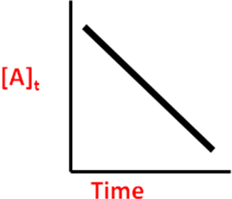  $\text{Rate}=−\frac{Δ\left[A\right]}{Δt}$  $\text{Rate}=k[A]^{0}$  [A]_{t} = -kt + [A]₀  (k) = M/s  First Order  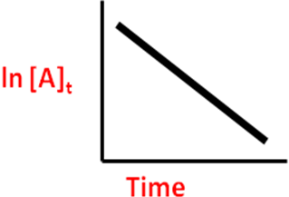  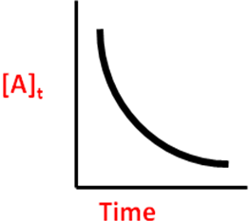  ln[A]_{t} = -kt + ln[A]_{0 or} log[A]_{t} = -kt / 2.303 + log[A]₀  (k) = s⁻¹  1 = kt + 1  [A] [A]₀  Second Order  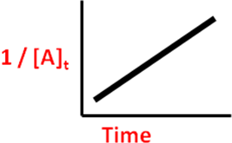  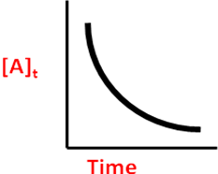  $\text{k }=\frac{\text{ln 2}}{t_{\text{1/2}}}=\frac{0\text{.}\text{693}}{t_{\text{1/2}}}$Half Life  Activation Energy  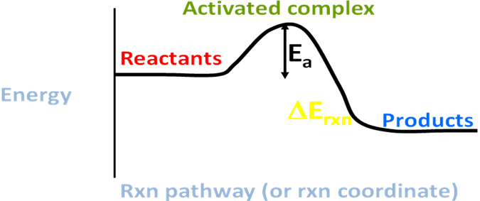$\text{Slope}=\frac{−E_{a}}{R}$  For slopes of linear graphs of reaction rate
  Experiment | [A] | [B] | Initial Rate of Formation of  C in M
  1 | 0.60 | 0.15 | 6.3´10⁻³
  2 | 0.20 | 0.60 | 2.8´10⁻³
  3 | 0.20 | 0.15 | 7.0´10⁻⁴
Summary of the Chapter and Important things to remember:

